

<Project Name- COMP7780/Project ID-2>

Backlog
Version 0.1
10/02/2026

Document Tracking
The following chart is used to log of all changes made to this document.
Version | Date of edit/change | Who made the edit/change | Description of edit/change
0.1 | Jan 10, 2022 | Hans Yip (PM) | Initial version
0.2 | Jan 15, 2022 | Hans Yip (PM) | Added requirement information
0.3 | Feb 1, 2022 | Hans Yip (PM) | Added first iteration information and priority information
0.4 | Feb 25, 2022 | Hans Yip (PM) | Added first iteration completion information
0.5 | Feb 26, 2022 | Hans Yip (PM) | Added second iteration information and priority information
0.6 | Mar 11, 2022 | Hans Yip (PM) | Modified second iteration completion information
0.7 | Mar 19, 2022 | Hans Yip (PM) | Added third iteration information and priority information

Introduction
Green World company is a new re-cycling concept organization based in Hong Kong which established on Jan 1, 2026.
Green World’s products were donated by the public and sell to the public with discounted price.
So far, customers need to visit the physical stores to purchase the products.
Green World would like to sell products online and would like to set up an E-shop/website to display their company’s information, product information and be able to sell products online if possible.

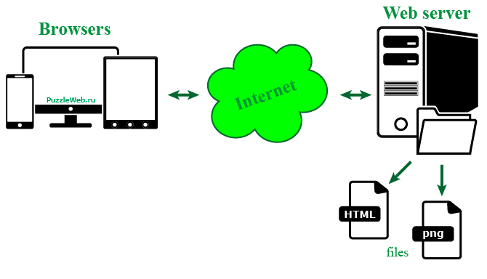

Backlog

Backlog# | Description  Or feature | Iteration # | Date open | Date Complete | Priority (1-5) | Status
R1 | Set up web site to display company and product information | 1 | Feb 1, 2026 | Feb 26, 2026 | 1
R2 | Display company information (comp7780_home.html) | 1, 2 | Feb 1, 2026 | Mar 11, 2026 | 1, 1
R3 | Display product information (comp7780_product.html) | 1, 2 | Feb 1, 2026 | Mar 11, 2026 | 1, 1
ITR1 | Set up Node.js web server | 1, 2 | Feb 1, 2026 | Mar 11, 2026 | 1, 1
ITR2 | Setup MySQL Database | 1, 2, 3 | Feb 1, 2026 |  | 4, 4, 1
R4 | Allow PayPal payment | 1, 2, 3 | Feb 1, 2026 |  | 5, 5, 2
R5 | Allow online order | 1, 2, 3 | Feb 1, 2026 |  | 4, 4, 1

